There are multiple ways to build a business around CodeAwareness or its core technology. Here are a few models we could consider:

**1. SaaS for Software Teams**

* **Business Model:** Subscription-based pricing per user/month.
* **Target Market:** Startups, mid-sized tech companies, enterprises with large dev teams.
* **How It Works:**
  + Offer a hosted version of CodeAwareness that integrates with GitHub, GitLab, Bitbucket.
  + Provide additional analytics on collaboration, code velocity, and team productivity.
  + Allow enterprise teams to self-host for compliance needs (e.g., SOC 2, GDPR).

🔹 **Potential Pricing:**

* Free for up to 3 users.
* $10/user/month for small teams.
* $25/user/month for enterprise teams with advanced features.

**2. AI-Powered Code Management for Enterprises**

* **Business Model:** Custom enterprise licensing + AI-driven development insights.
* **Target Market:** Fortune 500, regulated industries (finance, healthcare).
* **How It Works:**
  + AI-powered auto-commit, auto-merge, and predictive testing.
  + Code quality heatmaps and automated refactoring suggestions.
  + Compliance & security alerts for financial, government, and healthcare companies.

🔹 **Pricing:**

* Custom enterprise pricing ($50k+/year) with dedicated support.

**3. GitOps & DevOps Enhancement**

* **Business Model:** DevOps tool integrations (e.g., GitHub Actions, Jenkins plugins).
* **Target Market:** DevOps engineers, site reliability engineers (SREs).
* **How It Works:**
  + CodeAwareness integrates into CI/CD pipelines to enable real-time code tracking.
  + Automatic rollback suggestions based on conflicts.
  + Intelligent branch merging & AI-assisted conflict resolution.

🔹 **Pricing:**

* Free for individuals.
* Paid integrations ($15/user/month) for teams.

**4. Open Source + Premium Features**

* **Business Model:** Open-source core + paid premium features.
* **Target Market:** Open-source communities, self-hosted teams.
* **How It Works:**
  + Basic real-time awareness is free & open source.
  + Paid features include AI-powered code recommendations, Slack integration, and analytics dashboards.

🔹 **Pricing:**

* Free community edition.
* $99/month for premium analytics & AI features.

**5. Code Collaboration for Non-Developers (Writers, Designers, PMs)**

* **Business Model:** SaaS product for collaborative document editing (like Figma for code).
* **Target Market:** Marketing teams, content creators, legal teams.
* **How It Works:**
  + CodeAwareness expands beyond code: Word, Excel, PowerPoint, Notion integrations.
  + Enables real-time document tracking and collaborative editing without merge conflicts.

🔹 **Pricing:**

* $12/user/month for business teams.
* Enterprise pricing for large organizations.

## Source: 2023 [**https://www.cloudzero.com/blog/saas-statistics/**](https://www.cloudzero.com/blog/saas-statistics/)

1. SaaS spending will grow to $232 billion in 2024 (source: Gartner)

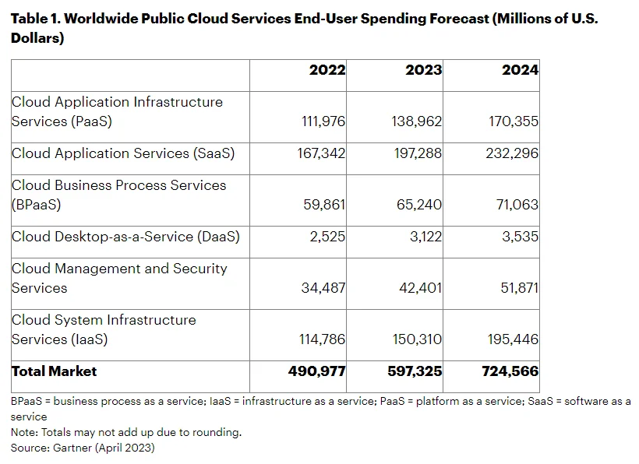

1. SaaS solutions will make up 85% of all business software in 2025 (source: BetterCloud)
2. Productivity and collaboration solutions dominate the SaaS market (source: Vainu)  
   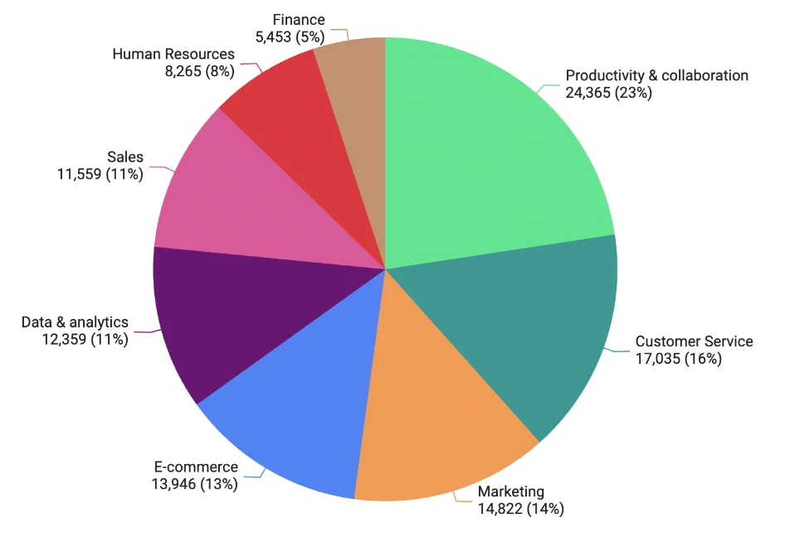
3. Among major markets, Germany’s SaaS market will grow the most, from €6.85 billion to €16.3 billion. (Statista)
4. There may be over 72,000 SaaS companies worldwide (source: Vainu)
5. What are the most purchased SaaS apps today (source: Vainu)  
     
   Vainu processed over $2.5 billion in software spend in 2022. It reported that the most purchased apps were CaptivateIQ (for commissions tracking), TripActions, Gong, Lattice, 6sense, Docker Desktop, and Kandji.

Security software led the park with Snyk, FloQast, Greenhouse, Okta, Highspot, Crowdstrike, Auth0, and SentinelOne. Data solutions also contributed significantly with Fivetran, Snowflake, and Datadog. Other top performers on Vainu included Drift (for conversational marketing and sales) and Jamf PRO (for Apple device management and security).  
  
Vainu shared 20 of the most renewed SaaS solutions based on payments it processed for them. Slack, DocuSign, Zoom, ZenDesk, LucidChart, Salesforce, and Culture Amp were among the top renewed solutions.

## Source: 2024 <https://zylo.com/blog/saas-statistics/>

* Global SaaS Market Growth: The global SaaS market is expected to hit $300 billion by 2025, fueled by an annual growth rate exceeding 20%​​.
* SaaS Adoption at Scale: Enterprises today manage an average of 275 SaaS applications, with IT overseeing just 26% of spend—a 6.4% drop over 2024​​.
* $18M wasted annually on unused licensesLicense Utilization Challenges: Alarmingly, organizations use only 47% of their SaaS licenses, wasting $21 million annually in unused licenses​​.
* Dynamic SaaS Portfolios: On average, six new SaaS applications enter organizations monthly, adding complexity to procurement and governance processes​.
* Renewal Overload: Organizations handle an average of 247 SaaS renewals per year—roughly one per business day​​.